

CFC SOC Logging Guidelines

Version 4.0

Intended Audience: This guidance is intended to establish a uniform set of requirements for SOC Logging.

This is an evolving document and should be updated as needed and assessed at least annually to ensure that it continues to conform to leading practices and reflects Lilly’s learnings and needs.

Document Management

Document Owner
Owners | Contact Name | Role | Date
Hai Yu Luo | Hai Yu Luo | Associate Director - China Cyber Business Lead | 9/8/2025

Summary of Changes
Version | Date | Change Description
1.0 | 12/13/2021 | Initial Draft
2.0 | 7/6/2022 | Update:  description for log ingestion like PA log integration and API log collection
3.0 | 3/1/2023 | Updating SOC Logging Context & Test cases
4.0 | 9/8/2025 | Updating Graph1 SOC Logging Context / Graph2 App SOC Integration Flow / SOC Logging Requirement Definition / SOC Log Requirements / China SOC log scope

Document Approver / Reviewer
Name | Title | Role | Signature | Dates
Hai Yu Luo | Associate Director-Information Security | Approver
Yun Heai Mun | Executive Director - IDS IBU Enterprise Architecture | Reviewer
Michael Timothy Kromm | Director - Global Lead Analyst | Reviewer

Contents
1 Document Management 2
1.1. Document Owner 2
1.2. Summary of Changes 2
1.3. Document Approver / Reviewer 2
2. Introduction 4
2.1 Purpose 4
2.2. Definitions 4
2.4. Audience 4
2.5. References 4
3. Overview 5
4. Documentation requirements 6
4.1 SOC Logging Requirement 6
4.2 SOC logging requirement in Security Plan 14
4.3 SOC logging test script in Application Test Cases 20

Introduction

2.1 Purpose
China Future Cloud (CFC) Security Operation Centre (SOC) is intended to offer a centralized log analysis solution. The service is provided by third party, Deloitte. The purpose of this document is to,
- Document China Security Operation Centre (SOC) log design per Lilly requirements and local regulation requirements.
- SOC log ingestion design between Lilly and Deloitte.
- Provide the guidance on SOC logging documentations, e.g. requirement, security plan, system level test cases.

2.2. Definitions
Provide the definition of any terms, acronyms and abbreviations required to properly interpret this document.

Security Operation Centre (SOC) | A security operations centre (SOC) hosts cyber security teams that are responsible for continuously monitoring and analysing Eli Lilly’s security posture. This team will detect, analyse, and respond to cybersecurity incidents.
China Future Cloud (CFC) | The China Future Cloud project is dedicated to design and implement an isolated China Cloud environment for business applications and data. This effort seeks to stand up the necessary foundational infrastructure, migrate China applications into China public cloud.

2.4. Audience
The audience of the guidelines is any employees from Lilly China Tech@Lilly team and partners involved in an IT system development and validation on China Future Cloud environment.

2.5. References
Ref | Document | Relationship
1 | LQP-302-26 – Computer System Delivery | This Standard Operating Procedure (SOP) defines the required stages in validation and lays a foundation for the SOC logging guidelines.
2 | LQP-302-29 – Computer System and Platform Security | This Standard Operating Procedure (SOP) offers the definition of security plan. The requirement demonstrated in this SOC logging guidelines are aligned with the requirements defined within this Computer System and Platform Security SOP.

Overview
The SOC log contains a chronological record of security-related events, activities, and incidents monitored and analysed by the SOC team. It serves as a valuable source of information for investigating security incidents, identifying trends, and evaluating the effectiveness of security controls. Per alignment, SOC log includes entries such as:
- Application log: Application logs refer to the records or entries generated by software applications to capture and store information about their activities, events, and errors.
- Network logs: Network logs are records or entries that capture information about network activity, communication, and events occurring within a computer network.
- Platform logs: Platform logs refer to the logs generated by software platforms or operating systems.
- Access logs: Known as server access logs or web server logs, are records that capture information about requests made to a web server or any other server that handles incoming requests.
- Database logs: Database logs are records that capture information about activities and transactions occurring within a database management system (DBMS).
3.1 SOC log Details:
Category | Log Type | China/Global | Purpose | Retention (minimum) | Responsible for generating logs | SOC Log route | Comment
Application Logs | Login | China&Global | Login logs for users | 365 days | China team | CloudWatch to S3
 | MACD log | China&Global | Move/Add/Change/Delete, record the administrators' operations. Follow application data record retention. | 365 days | China team | CloudWatch to S3
 | User Action log | China&Global | Record user operations, e.g., user visit | 365 days | China team | CloudWatch to S3
 | API log | China&Global | Record events occur during the execution of an API request or response | 365 days | China team | CloudWatch to S3
Database Logs | Database log | China&Global | At China CFC, now we have database of Aurora PostgreSQL only | 365 days | DC - EIP team | CloudWatch to S3
Network Logs | Firewall log | China&Global | Record Internet/Intranet activities through PA firewall | 365 days | DC - GNS team | Directly to S3 | Unique ingestion solution due to no use of Splunk
 | VPC Flow Log | China&Global | Record Network flow | 365 days | DC - GNS team | Directly to S3
 | WAF log | China&Global | Record Detailed about traffic that is analyzed by web ACL | 365 days | China Team | Directly to S3
Platform logs | OS log | China&Global | Record operating system (OS) events | 365 days | China Team | EC2 To s3
 | Qualys log | Global | Record Qualys Component event | 365 days | China Team | NA
 | AWS services log | China&Global | Record AWS components events | 365 days | DC - GNS team | Directly to S3 | E.g., CloudTrail, GuardDuty, Config
Access logs | S3 Access logs | China&Global | Record User operations to S3 | 365 days | China team | replicate to S3
 | China Azure logs | China&Global | Record Patient CRM & China Azure AD events | 365 days | IS - IAM team | AKSK to S3 | for China Azure AD app.
 | SG Azure logs | Global | Record SingaporeAzure AD events | 365 days | IS - IAM team | NA

3.2 SOC Integration Flow
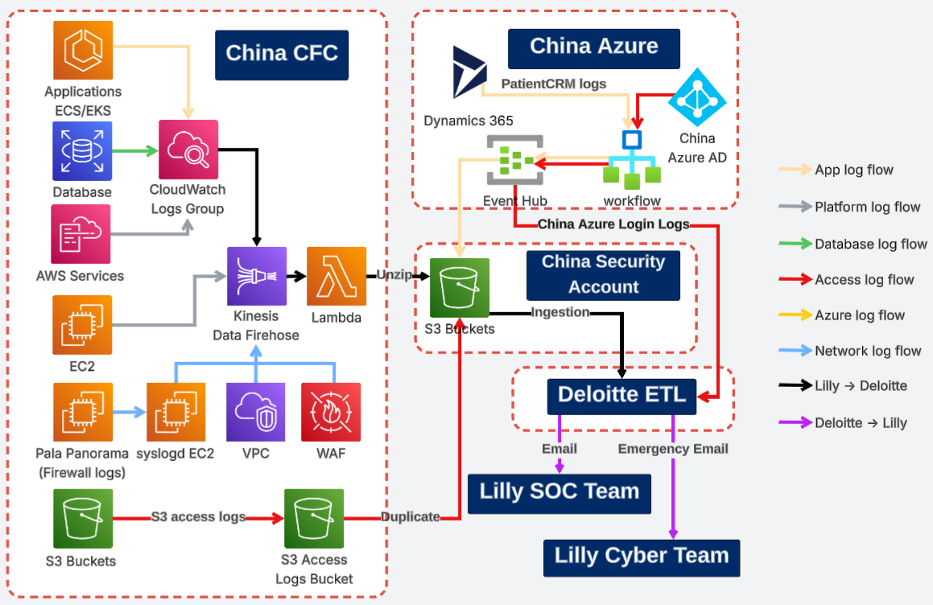

Incident Emergency Response
In case SOC Tier1 identifies a highly critical and urgent incident with confirmed validity (classified as an emergency incident, such as those involving severe impact, immediate threat, or widespread disruption), the team must promptly notify the Lilly China SOC team and also send an email to Lilly Cyber at cyber@lilly.com (e.g., crypto-mining on production servers, APT attacks targeting sensitive assets, ransomware affecting core systems, large-scale data breaches involving PII).

Documentation requirements
All applications which hosted on China Future Cloud environment are required to generate the SOC log and integrate with Deloitte SIEM platform for log monitoring.

5.1 SOC Logging Requirement
This section defines SOC logging requirements that must be fulfilled. It contains details of required information includes but are not restricted log format, repository, and additional documentation guidelines. Sample logs are offered in this section as well. SOC log requirements should be combined with system requirement in one document.

Ref. No | Log Category | Requirements | Release | Criticality
LOG-1 | [AUDIT] [Login] | Logs used to track login user records  - 用户登录，系统会记录登录日志  - 存储在Cloud Watch  - 日志格式包含信息展示如下。  - 如果用户登陆失败，需要记录下列字段信息。这包括存在Active Directory但无应用系统登陆权限的用户登陆失败的情况。  TimeStamp EventCode Audit Type Description User Identifier Login IP Failure Example  (必填 项) (必填 项) (必填 项) Login Login without authorization User Identifier(必填项) Login IP (必填 项) Unauthorized 2021-09-24T00:39:08.792 [18] [AUDIT] [Login] odkmf1MjNraZT4qZVbo-aZG3cSiY 182.204.40.243 unauthorized  - 如果用户访问成功， 需要记录下列字段信息。  Timestamp EventCode Audit Type Description User Identifier Login IP Optional Example  (必填 项) (必填 项) (必填 项) Login Login Successfully User Identifier(必填项) Login IP (必填项) 2021-09-24T00:39:08.792 [18] [AUDIT] [Login] odkmf1MjNraZT4qZVbo-aZG3cSiY 182.204.40.243 | 1 | CIT
LOG-2 | [AUDIT] [API] | Logs used to track inbound and outbound API records  记录信息包含：  - Information of this system’s API that any other platforms will invoke  对于其他平台调用本系统API的场景，审计日志信息记录下列字段  Timestamp EventCode Audit Type Description API Path IP Parameter Example  (必填 项) (必填 项) (必填 项) API Other system invokes this system’s API API Path (必填项) IP of the other platform invoking this API (必填项) Parameter passed when calling this API (选填项) 2021-09-24T00:39:08.792 [25] [AUDIT] [API] /api/mpwechat/v1/wechat/ &openid=o8LkywK4182.204.40.243 81.69.103.2053  - Information of this system’s API that any other platforms will invoke  对于本系统调用其他平台API的场景，审计日志信息记录下列字段  Timestamp EventCode Audit Type Description API Path Parameter Optional Example  (必填 项) (必填 项) (必填 项) API This system invokes other systems’ API API Path (必填项) Parameter passed when calling this API (选填项) 2021-09-24T00:39:08.792 [35] [AUDIT] [API] https://4xtuc2htoc. execute-api.cn.amazonaws.com .cn/prd/hcp | 1 | CIT
LOG-3 | [AUDIT] [EndUser] | Logs tracks security related end user behavior  Timestamp EventCode Audit Type Description User Identifier Operation Operated Data Example  (必填 项) (必填 项) (必填 项) EndUser User Behavior User Identifier (必填项) Operation (必填项) Data Being operated(选填项) 2021-09-23T02:14:37.678 [19] [AUDIT] [EndUser] o8056dfsai subscribe | 1 | CIT
LOG-4 | [AUDIT] [MACD] | This log contains details of backend management admin maintenance information.  Timestamp EventCode Audit Type Description User Identifier Operation Operated Data Example  (必填 项) (必填 项) (必填 项) MACD Backend management admin behaviour User Identifier (必填项) Operation (必填项) Data Being operated(选填项) 2021-09-23T02:14:37.678 [19] [AUDIT] [MACD] l@lilly.com updateNurse Approve 11233 | 1 | CIT
LOG-5 | [AUDIT] [Log Inventory] | Security logs must not be changed, removed, or turned off. | 1 | CIT
LOG-6 | [AUDIT] [Log Inventory] | The following elements must be documented:  a. description of where the application logs are retained and for what period,  b. roles that can access the logs and the type of access held (e.g., read, write, update).  These items can be documented in security plan. | 1 | CIT
LOG-7 | [AUDIT] [Log Inventory] | Document if sensitive or confidential information is captured in logs. This can be documented in security plan. | 1 | CIT
LOG-8 | [AUDIT] [Log Inventory] | Column separators of LOG1 to LOG4 must be a single blank space. e.g., “ColumnA ColumnB ColumnC” | 1 | CIT
LOG-9 | [AUDIT] [Log Inventory] | All these log files must be pushed to AWS CloudWatch service. | 1 | CIT
LOG-10 | [AUDIT] [Log Inventory] | A description of any log reviews and/or monitoring must be documented, including:  a. roles responsible for review,  b. review frequency  This can be documented in security plan. | 1 | CIT
LOG-11 | [AUDIT] [Log Inventory] | App logs must adhere to the naming convention of log files in AWS S3 bucket as either one of the following:  Naming Standard Example  Bucketname/Application Name/Year/Month/Day/Hour/File lilly-d365logs-prod-cn-northwest-1/PatientCRM/2021/12/08/02/log_file  Bucketname/ApplicationName/channels/Year/Month/Day/Hour/File lilly-applogs-prod-cn-northwest-1/iDoctor/wechat/2021/12/08/02/log_file
LOG-12 | [AUDIT] [Log Inventory] | Must set the SOC log file format as csv or text. It must not be compressed as zip in AWS S3 bucket. | 1 | CIT
LOG-13 | [AUDIT] [Log Inventory] | Document in security plan for any gaps identified from LOG-1 to LOG-4 | 1 | CIT

5.2 SOC logging requirement in Security Plan
Security plan is a critical document as defined in “LQP-302-29 – Computer System and Platform Security” [2], since it explains system design related to security management and therefore, it lays a solid foundation for system validation. The following section should be documented in system security plan.
Log Name | [Name]  1.[AUDIT] [Login]  2.[AUDIT] [API]  3.[AUDIT] [EndUser]  4.[AUDIT] [MACD]
Log Description & Format | [Description]  1.[AUDIT] [Login]: this log contains details of a user’s login attempts, including successful login attempts and unauthorized login requests. 该日志保存在CloudWatch中，下表中列出了存在CloudWatch的日志所需字段及格式。  - 如果用户访问成功， 审计日志需要记录下列字段信息。  Timestamp EventCode Audit Type Description User Identifier Login IP Optional Example  (必填 项) (必填 项) (必填 项) Login Login Successfully User Identifier(必填项) Login IP (必填项) 2021-09-24T00:39:08.792 [18] [AUDIT] [Login] odkmf1MjNraZT4qZVbo-aZG3cSiY 182.204.40.243  - 如果用户登陆失败，需要记录下列字段信息。这包括存在Active Directory但无应用系统登陆权限的用户登陆失败的情况。  Timestamp EventCode Audit Type Description User Identifier Login IP Failure Example  (必填 项) (必填 项) (必填 项) Login Login without authorization User Identifier(必填项) Login IP (必填 项) Unauthorized 2021-09-24T00:39:08.792 [18] [AUDIT] [Login] odkmf1MjNraZT4qZVbo-aZG3cSiY 182.204.40.243 unauthorized  2.[AUDIT] [API]: this log contains the following information about this system’s API that any other platforms will invoke and the API of other platforms that this system will call. 该日志保存在CloudWatch中，下表中列出了存在CloudWatch的日志所需字段及格式。  - Information of this system’s API that any other platforms will invoke.  对于其他平台调用本系统API的场景，审计日志信息记录下列字段  Timestamp EventCode Audit Type Description API Path IP Parameter Example  (必填 项) (必填 项) (必填 项) API Other system invokes this system’s API API Path (必填项) IP of the other platform invoking this API (必填项) Parameter passed when calling this API (选填项) 2021-09-24T00:39:08.792 [25] [AUDIT] [API] /api/mpwechat/v1/wechat/ &openid=o8LkywK4182.204.40.243 81.69.103.2053  - Information of this system’s API that any other platforms will invoke.  对于本系统调用其他平台API的场景，审计日志信息记录下列字段  Timestamp EventCode Audit Type Description API Path Parameter Optional Example  (必填 项) (必填 项) (必填 项) API This system invokes other systems’ API API Path (必填项) Parameter passed when calling this API (选填项) 2021-09-24T00:39:08.792 [35] [AUDIT] [API] https://4xtuc2htoc. execute-api.cn.amazonaws.com .cn/prd/hcp  [AUDIT] [EndUser]：this log contains security related end users’ behaviour information. 该日志保存在CloudWatch中。下表中列出了存在CloudWatch的日志所需字段及格式。  Timestamp EventCode Audit Type Description User Identifier Operation Operated Data Example  (必填 项) (必填 项) (必填 项) EndUser User Behavior User Identifier (必填项) Operation (必填项) Data Being operated(选填项) 2021-09-23T02:14:37.678 [19] [AUDIT] [EndUser] o8056dfsai subscribe  4. [AUDIT] [MACD]：this log contains details of backend management admin maintenance information. 该日志保存在CloudWatch中。下表中列出了存在CloudWatch的日志所需字段及格式。  Timestamp EventCode Audit Type Description User Identifier Operation Operated Data Example  (必填 项) (必填 项) (必填 项) MACD Backend management admin behaviour User Identifier (必填项) Operation (必填项) Data Being operated(选填项) 2021-09-23T02:14:37.678 [19] [AUDIT] [MACD] l@lilly.com updateNurse Approve 11233
 | Log Captures | Details | *Explanation of Gap if information Not captured in log
Log Ability to Capture | ☐ When  ☒ When | Date and Time of Access
 | ☐ Who  ☒ Who | Who tried to access the system
 | ☐ From  ☒ From | IP address of device used to access system
Log Retention | CFC CloudWatch application log groups → CFC Security account S3 buckets |  | Duration | Follow system retention
Logging Mechanism | This application supports syslogs. The log files are to be automated generated by the system in real-time
Roles that can access logs | Only China local security roles and Global AWS Cloud Foundation team roles (Managing CFC security account) can access CFC Security account S3 bucket.
Type of Access(Read, Write, Update) | Read Only and no one can modify the logs
Sensitive and confidential Information | NA
* Risks associated with not meeting any of the controls must be addressed

5.3 SOC logging test script in Application Test Cases
The following is the general test script for SOC log integration testing. At least, every application should follow below steps to verify the integration, to ensure it is working appropriately.
TS - [Positive/Negative Test]: Log
System Name:
Test Run Number:

Test Case Steps
Pre-requisites
Step # | Test Case Description & Steps | Expected Result | Actual Result | Pass
Case_1 | 查看log存放位置 | APP Logs独立存放在CloudWatch文件夹下，如有其他业务数据文件，需要存储分离
Case_2 | 检查log文件生成 | Log每次重启记录在一个容器里
Case_3 | 登录操作log检查：  1. 正常账号系统登录成功，检查日志 | Azure Active Directory (AD) Lilly认证通过  Log 记录认证通过
Case_4 | 操作页面：  1.浏览访问功能页面，查看log  2.普通模块下，进行数据查询  3.普通模块下，进行数据修改  4.点击下载文档 | 1.log记录访问的页面和账号访问页面的时间  2.log记录用户在模块下的查询操作动作以及查询时间  3.log记录用户在模块下的动作，修改时间  4.记录用户在模块下下载文档的时间
Case_5 | 检查log文件会不会受到应用新发布的容器影响 | 不会受到应用新发布的容器影响
Case_6 | 检查系统运行job任务的log：  1.执行job成功，查看log  2.执行job失败，查看log | 1.记录job执行的开始时间、结束时间以及执行成功的结果  2. 记录job执行的开始时间、结束时间以及执行失败的结果
Case_7 | 执行邮件触发操作 | Log记录邮件发送记录
Case_8 | 系统异常记录：  1.切换本地网络，出现网络错误  2.注释部分代码，执行功能 | 1.log中有报错记录  2.log中有报错记录
Case_9 | 检查日志是否收集敏感或机密信息 | 1. log中有敏感或机密信息，但已经将相应安全控制机制文档化  2. log中没有记录敏感或机密信息
Case_10 | 检查访问日志的角色和相应权限 | 1. 相应角色对于日志的访问符合设计规范  2. 不存在角色或用户可以修改或者删除日志记录/文件
Case_11 | 校验日志列分隔符 | 日志列分隔符是单空格
Case_12 | 文档记录 | 验证以下信息均已记录：  日志保留周期，日志记录机制，访问角色。  日志审查描述及角色，频率和在出现异常时沟通升级的机制。  日志功能如果无法满足Case_15至Case_18，则需将存在的差距文档化。
Case_13 | 日志文件命名规范 | 验证AWS S3中的文件符合设计规范  Naming Standard Example  Bucketname/Application Name/Year/Month/Day/Hour/File lilly-d365logs-prod-cn-northwest-1/PatientCRM/2021/12/08/02/log_file  Bucketname/ApplicationName/channels/Year/Month/Day/Hour/File lilly-applogs-prod-cn-northwest-1/iDoctor/wechat/2021/12/08/02/log_file
Case_14 | 日志文件格式 | 验证AWS S3中的文件为csv或txt.并且为非压缩包格式
Case_15 | 检查Login类型日志格式和数据 | Login类型日志格式和数据符合设计规范  - 对于用户登陆失败的情况，日志准确记录了下列字段信息。这包括用户存在与Active Directory但无应用系统访问权限而登陆失败的情况。  TimeStamp EventCode Audit Type Description User Identifier Login IP Failure Example  (必填 项) (必填 项) (必填 项) Login Login without authorization User Identifier(必填项) Login IP (必填 项) Unauthorized 2021-09-24T00:39:08.792 [18] [AUDIT] [Login] odkmf1MjNraZT4qZVbo-aZG3cSiY 182.204.40.243 unauthorized  - 如果用户访问成功， 日志准确记录了下列字段信息.  TimeStamp EventCode Audit Type Description User Identifier Login IP Failure Example  (必填 项) (必填 项) (必填 项) Login Login without authorization User Identifier(必填项) Login IP (必填 项) Unauthorized 2021-09-24T00:39:08.792 [18] [AUDIT] [Login] odkmf1MjNraZT4qZVbo-aZG3cSiY 182.204.40.243 unauthorized
Case_16 | 检查API类型日志格式和数据 | API类型日志格式和数据符合设计规范  - Information of this system’s API that any other platforms will invoke  对于其他平台调用本系统API的场景，日志信息记录了下列字段  Timestamp EventCode Audit Type Description API Path IP Parameter Example  (必填 项) (必填 项) (必填 项) API Other system invokes this system’s API API Path (必填项) IP of the other platform invoking this API (必填项) Parameter passed when calling this API (选填项) 2021-09-24T00:39:08.792 [25] [AUDIT] [API] /api/mpwechat/v1/wechat/ &openid=o8LkywK4182.204.40.243 81.69.103.2053  - Information of this system’s API that any other platforms will invoke  对于本系统调用其他平台API的场景，日志信息记录了 下列字段  Timestamp EventCode Audit Type Description API Path Parameter Optional Example  (必填 项) (必填 项) (必填 项) API This system invokes other systems’ API API Path (必填项) Parameter passed when calling this API (选填项) 2021-09-24T00:39:08.792 [35] [AUDIT] [API] https://4xtuc2htoc. execute-api.cn.amazonaws.com .cn/prd/hcp
Case_17 | 检查Enduser类型日志格式和数据 | EndUser类型日志格式和数据符合设计规范  Timestamp EventCode Audit Type Description User Identifier Operation Operated Data Example  (必填 项) (必填 项) (必填 项) EndUser User Behavior User Identifier (必填项) Operation (必填项) Data Being operated(选填项) 2021-09-23T02:14:37.678 [19] [AUDIT] [EndUser] o8056dfsai subscribe
Case_18 | 检查MACD类型日志格式和数据 | MACD类型日志格式和数据符合设计规范  Timestamp EventCode Audit Type Description User Identifier Operation Operated Data Example  (必填 项) (必填 项) (必填 项) MACD Backend management admin behaviour User Identifier (必填项) Operation (必填项) Data Being operated(选填项) 2021-09-23T02:14:37.678 [19] [AUDIT] [MACD] l@lilly.com updateNurse Approve 11233
Case_19 | 在应用上线前，按照Playbook指导运行所有的日志检测规则项目，通过配置的AWS脚本运行结果，确认日志中不存在特定格式的 key/secret/password/AKSK、AAD Token/Decoded Secret、患者姓名、患者血糖数据、医生姓名、电话号码这几种敏感信息。  这些检测规则可以且只能检测和统计下列格式的敏感数据，如有其他格式，则需要进一步开发新的规则：  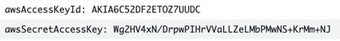  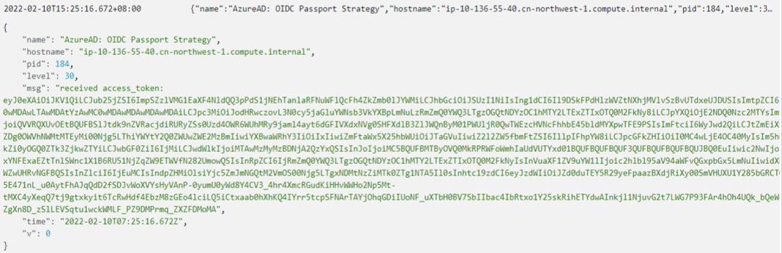 | 运行所有检测规则后，无结果显示：  